Diclofenac is a member of the acidic antipyretic analgesics group (pain agents). Like all representatives of this class, Diclofenac inhibits cyclooxygenases (COX) and thus reduces prostaglandin synthesis, which influences peripheral pain formation¹. Because it is an active ingredient in pain-relieving ointment, Diclofenac enjoys a great popularity among the German population. These have been amongst the most popularly sold drugs in Germany² for many years.

In addition, Diclofenac has an anti-phlogistic anti-rheumatic effect and is counted among the non-selective non-steroidal anti-inflammatory drugs (non-selective NSAID) due to its inhibitory effect on both COX isoenzymes (COX-1 and COX-2). In Germany, Diclofenac is the most common administered active ingredient^{1.}used to treat rheumatic arthritis.

The wide application, primarily within Germany, generates a consumption of about 90 tons per year in Germany. This high consumption has costs however, as only about 30 % of the active substance is metabolized by the human body, the rest being excreted unchanged in urine. This leads to an estimated 63 tons of Diclofenac per year in Germany enter the water cycle³.

Due to its high stability and water solubility, Diclofenac is poorly filtered out in conventional wastewater treatment plants. Although Diclofenac does not pose an acute danger to humans in the concentrations for which it is found in German waters, it is highly toxic to aquatic organisms. More modern sewage treatment plants are trying to solve this problem by additional purification (ie nanofiltration, ozone or activated carbon). In addition to the high costs, the lack of experimental data on emerging products in the application of non-specific degradation methods, such as ozone, make these far from ideal. Recent work, including our project, have set themselves the objective of investigating the use of enzymes as catalysts for the degradation of micropollutants such as Diclofenac^{3,4}.

We therefore hope to establish a self-sustaining, enzyme-based system, which is characterized by a high turnover rate, low maintenance and low costs. In addition, the use of enzymes and the specificity associated with them should make it predictable which reaction products are produced during the degradation of Diclofenac, so that a disruption of environmental homeostasis by possibly toxic products can be avoided.

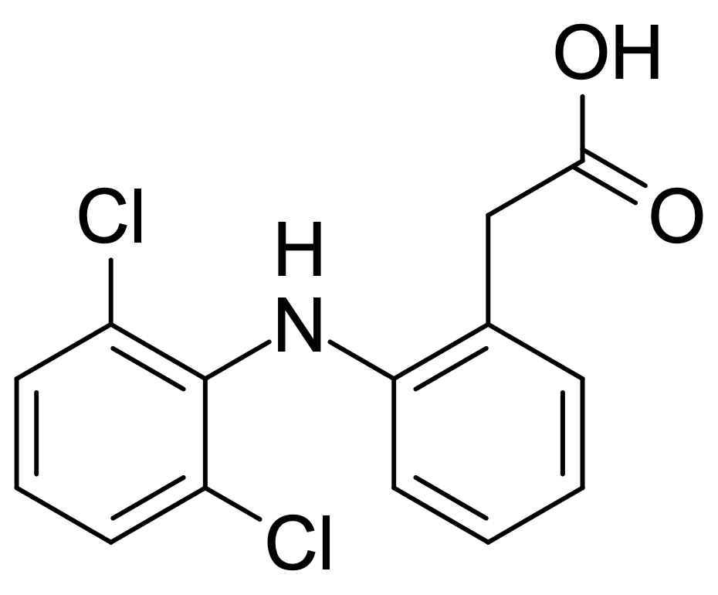
Structure of Diclofenac, created in MarvinSketch, version 20.2.0, developed by ChemAxon, https://chemaxon.com/products/marvin, 2020.

(1) Acctories, K.; Förstermann, U.; Hofmann, F.; Strong, K. General and Special Pharmacology And Toxicology, 9th edition.; Urban & Fischer Verlag: Munich, 2005.
(2) Glaeske, G. Drugs 2015 – Psychotropic and Other Medicines With Potential for Abuse and Addiction. Yearb. Search 2017.
(3) Meißner, M. Medicines in The Environment: Nature as a drug dump. Dtsch Arztebl Int. 2008, 105 (24), A-1324.
(4) Bilal, M.; Adeel, M.; Rasheed, T.; Zhao, Y.; Iqbal, H. M. N. Emerging Contaminants of High Concern and Their Enzyme-Assisted Biodegradation – A Review. Environment International. 2019. https://doi.org/10.1016/j.envint.2019.01.011.

